**Project Planning Phase**

**Project Planning Template (Product Backlog, Sprint Planning, Stories, Story points)**

|  |  |
| --- | --- |
| Date | 25 October 2023 |
| Team ID | Team-593212 |
| Project Name | Deep Learning Fundus Image Analysis For Early Detection Of Diabetic Retinopathy |
| Maximum Marks | 20 Marks |

**Product Backlog, Sprint Schedule, and Estimation (4 Marks)**

Use the below template to create product backlog and sprint schedule

|  |  |  |  |  |  |  |  |  |  |  |  |  |  |  |
| --- | --- | --- | --- | --- | --- | --- | --- | --- | --- | --- | --- | --- | --- | --- |
| **Sprint** | **Functional**  **Requirement (Epic)** | | | | **User Story Number** | **User Story / Task** | | | | |  | **Story Points** | **Priority** | **Team**  **Members** |
| Sprint-1 |  | Project setup & | |  | USN-1 | Set up the development environment with the required tools and frameworks to start the garbage classification project. | | | | |  | 1 | High | Hari |
| Infrastructure |  |
| Sprint-1 | development environment | | | | USN-2 | Gather a diverse dataset of images containing different types of garbage (plastic, paper, glass, organic) for training the deep learning model. | | | | |  | 2 | High | Hari |
| Sprint-2 | Data collection | | | | USN-3 | Preprocess the collected dataset by resizing images, normalizing pixel values, and splitting it into training and validation sets. | | | | |  | 2 | High | Mahidhar |
| Sprint-2 | data preprocessing | | | | USN-4 | Explore and evaluate different deep learning architectures (e.g., CNNs) to select the most suitable model for garbage classification. | | | | |  | 3 | High | Saumya |
| Sprint-3 | model development | | | | USN-5 |  | train the selected deep learning model using the preprocessed | | |  |  | 4 | High | Hari |
| dataset and monitor its performance on the validation set. | |  |
| Sprint-3 | Training | | | | USN-6 |  | implement data augmentation techniques (e.g., rotation, flipping) | | | |  | 6 | medium | Saumya |
| to improve the model's robustness and accuracy. |  | | |
| Sprint-4 | model deployment &  Integration | | | | USN-7 | deploy the trained deep learning model as an API or web service to make it accessible for garbage classification. integrate the model's API into a user-friendly web interface for users to upload images and receive garbage classification results. | | | | |  | 1 | medium | Shivam |
| Sprint-5 | Testing & quality assurance | | | | USN-8 | conduct thorough testing of the model and web interface to identify and report any issues or bugs. fine-tune the model hyperparameters and optimize its performance based on user feedback and testing results. | | | | |  | 1 | medium | Srikanth |

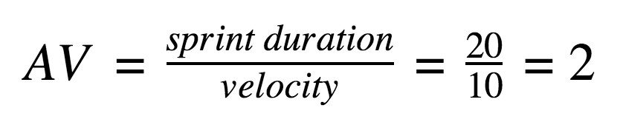**Project Tracker, Velocity & Burndown Chart: (4 Marks)**

|  |  |  |  |  |  |  |
| --- | --- | --- | --- | --- | --- | --- |
| **Sprint** | **Total Story Points** | **Duration** | **Sprint Start Date** | **Sprint End Date (Planned)** | **Story Points**  **Completed (as on**  **Planned End Date)** | **Sprint Release Date (Actual)** |
| Sprint-1 | 3 | 3 Days | 1 Sep 2023 | 3 Sep 2023 | 20 | 3 Sep 2023 |
| Sprint-2 | 5 | 5 Days | 4 Sep 2023 | 8 Sep 2023 |  |  |
| Sprint-3 | 10 | 7 Days | 9 Sep 2023 | 15 Sep 2023 |  |  |
| Sprint-4 | 1 | 7 Days | 16 Sep 2023 | 19 Sep 2023 |  |  |
| Sprint-5 | 1 | 7 Days | 19 Sep 2023 | 25 Sep 2023 |  |  |
|  |  |  |  |  |  |  |
|  |  |  |  |  |  |  |
|  |  |  |  |  |  |  |

**Velocity:**

Imagine we have a 29-days sprint duration, and the velocity of the team is 20 (points per sprint). Let’s calculate the team’s average velocity (AV) per iteration unit (story points per day)

# AV= 29/20 = 1.45

**Burndown Chart:**

A burndown chart is a graphical representation of work left to do versus time. It is often used in agile [software](https://www.visual-paradigm.com/scrum/what-is-agile-software-development/) [development](https://www.visual-paradigm.com/scrum/what-is-agile-software-development/) methodologies such as [Scrum](https://www.visual-paradigm.com/scrum/scrum-in-3-minutes/). However, burn down charts can be applied to any project containing measurable progress over time.

[**https://www.visual-paradigm.com/scrum/scrum-burndown-chart/**](https://www.visual-paradigm.com/scrum/scrum-burndown-chart/) [**https://www.atlassian.com/agile/tutorials/burndown-charts**](https://www.atlassian.com/agile/tutorials/burndown-charts)

**Reference:**

[**https://www.atlassian.com/agile/project-management**](https://www.atlassian.com/agile/project-management)

[**https://www.atlassian.com/agile/tutorials/how-to-do-scrum-with-jira-software**](https://www.atlassian.com/agile/tutorials/how-to-do-scrum-with-jira-software) [**https://www.atlassian.com/agile/tutorials/epics**](https://www.atlassian.com/agile/tutorials/epics) [**https://www.atlassian.com/agile/tutorials/sprints**](https://www.atlassian.com/agile/tutorials/sprints) [**https://www.atlassian.com/agile/project-management/estimation**](https://www.atlassian.com/agile/project-management/estimation) [**https://www.atlassian.com/agile/tutorials/burndown-charts**](https://www.atlassian.com/agile/tutorials/burndown-charts)

**Burndown Chart:**

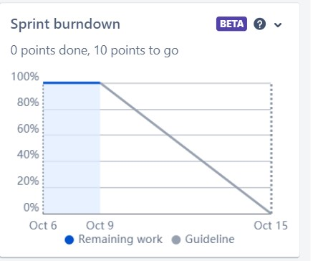

**Board section.**

We have completed sprint 1 and 2. So we can see the remaining tasks on board.

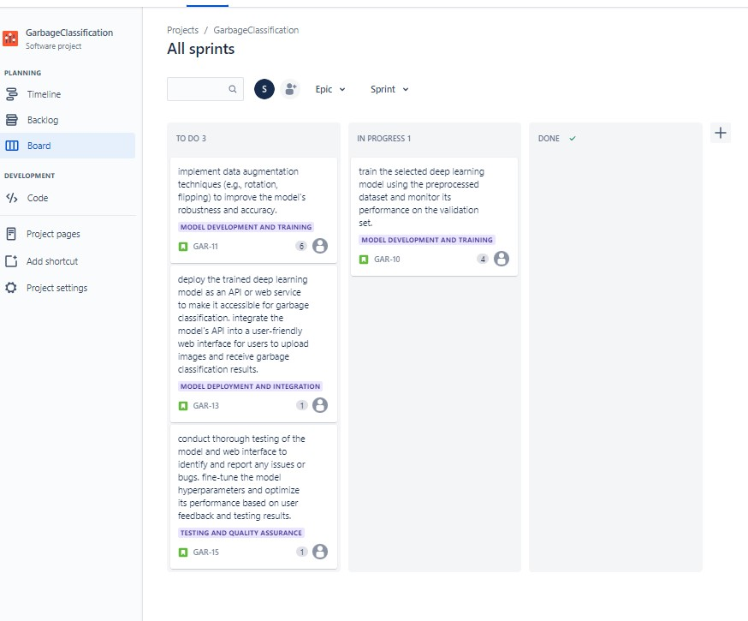

**Backlog section**

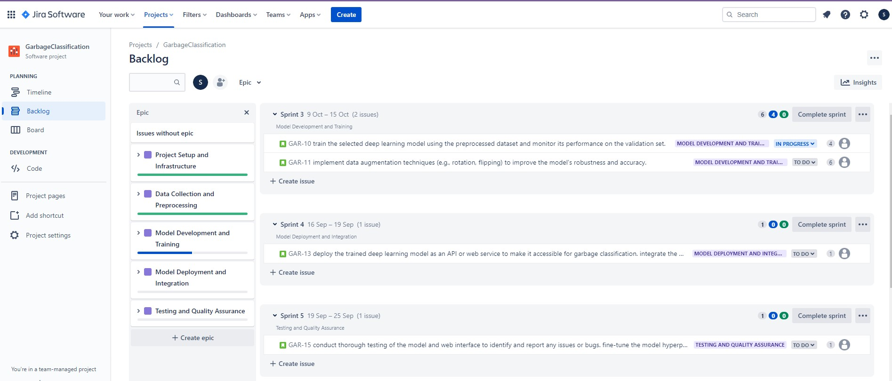

**Timeline**

